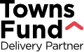

GOOD GOVERNANCE TOOL

A reflection exercise on how to get the most out of your Town Deal Board
Terms & Conditions

- This document has been developed by the Towns Fund Delivery Partner, a consortium led by Ove Arup & Partners Ltd with our partners, Grant Thornton UK LLP, Nichols Group Ltd, FutureGov Ltd, Copper Consultancy Ltd and Savills UK Ltd (collectively 'we'). The content of this document is for your general information and use only.
- Neither we nor any third parties provide any warranty or guarantee as to the accuracy, timeliness, performance, completeness or suitability of the information and materials found in this document for any particular purpose. You acknowledge that such information and materials may contain inaccuracies or errors and we expressly exclude liability for any such inaccuracies or errors to the fullest extent permitted by law.
- Your use of any information or materials contained in this document is entirely at your own risk, for which we shall not be liable.
- This document contains material which is owned by or licensed to us. This material includes, but is not limited to, the design, layout, look, appearance and graphics. Reproduction is prohibited other than in accordance with the copyright notice which can be found at townsfund.org.uk
- Unauthorised use of this document may give rise to a claim for damages and/or be a criminal offence.
- This document may also include links to other materials, websites or services. These links are provided for your convenience to provide further information. They do not signify that we explicitly endorse these materials, websites or services.
- Your use of this content and any dispute arising out of such use of the content is subject to the laws of England, Northern Ireland, Scotland and Wales.
- For formal Government guidance on Towns Fund please visit gov.uk

Introduction

What is this tool?  The Towns Fund provides an opportunity for transformational investment in your town and acts as a platform for future policy and development. Your Town Deal Board has an essential role to play and is responsible for producing Town Investment Plans and overseeing compliance with the Heads of Terms Agreement with the government. Therefore, it’s crucial that the board performs well.  This tool is designed to help you get the best from your board. It’s an opportunity for you to reflect on what a high performing board looks like, plan how you can support and improve your board and identify any extra support needs you may have.  The tool looks at the four themes which are core to good governance and high performing boards:  - working well as a board team  - working in the open  - engaging with relevant partners and the community  - making good decisions  It aims to support towns beyond the minimum governance standards from the Towns Fund guidance, which towns will need to demonstrate that they meet when they submit their TIPs. MHCLG colleagues will be separately working with towns to make sure they meet these minimum requirements. | Who is it for?  We know that each place is unique and each Town Deal Board is working slightly differently, but there are a number of common roles:  - The Town Deal Board Chair is responsible for leading the board in achieving its objectives, and ensuring that decisions are made by the board in accordance with good governance principles  - The Lead Council is also responsible for ensuring that decisions are made by the board in accordance with good governance principles  - All board members should work together and take collective responsibility for how they’re performing, and may want to discuss improvement actions they could take  What happens next?  This tool is for you, it’s not an assessment or an evaluation and you are not required to share the results with anyone.  Where you identify areas for improvement you can talk this through with your Town Coordinator who will direct you to additional support. They’d also like to hear where you think you have examples of working well that we could share with others. There may also be other people who can help you, such as the governance teams in the Council, LEP or CA and your local CLGU rep.

About this tool

How do I use it?

Within each of the four themes, this tool provides examples of what good looks like and asks you to reflect on whether this is happening in your Town Deal Board.

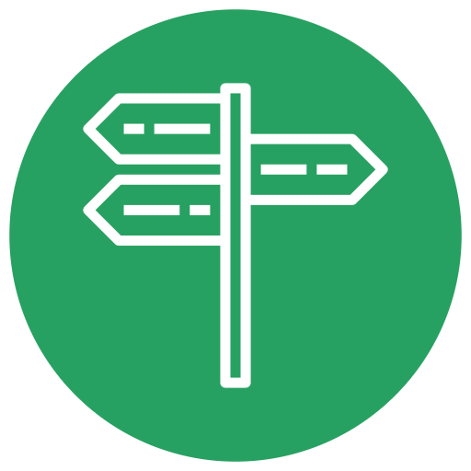  What the guidance says we need to do regarding roles and responsibilities | 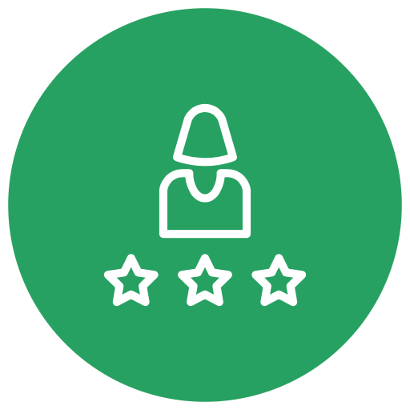  What does this feel like in terms of the experience of good governance? | How are we doing?
This lists the minimum governance standards related to the theme from the Towns Fund guidance. All towns will need to demonstrate that they’ve met these standards for their TIP to be approved. | This provides examples of good practice related to the theme, to help you stretch beyond the minimum requirements. It aims to give you examples that you can see, hear or feel so you can be objective about whether it’s happening in your board. | This is where you can record what you think you’re doing well, what you’d like to keep doing or build on and where you think there are areas you can improve. It’s for you, so be honest and try to give specific examples.

After each theme, there’s a section that includes four follow up questions designed to help you prioritise and focus on action.

- What aspects [of the theme] should you focus on to help improve your Town Deal Board?
- What do you think needs to change in these areas, and how?
- How will the board know that changes are having the desired impact?
- Do you have examples [of the theme] that you’d like to share with other boards?

1. Working well together as a board team

Roles and Responsibilities
What the guidance says we need to do | What does good feel like? | How are we doing?
We have clear roles and responsibilities for oversight of the Town Deal. | - Board members understand their own role and how it relates to the purpose of the group and the roles of other members  - Inside and outside board meetings, members take responsibility for delivering on their role and responsibilities  - We regularly check that everyone is clear about their role and responsibilities  - We adapt people’s roles and responsibilities, and board membership as and when circumstances change | (Write here)

Membership
What the guidance says we need to do | What does good feel like? | How are we doing?
The board’s membership reflects the diversity of the town and surrounding area and includes:  - a private sector chair  - all tiers of local government for the geography of the town  - the MP(s) representing the town  - the Local Enterprise Partnership  - local businesses and investors  - community/local voluntary community sector representatives  - other relevant local organisations, such as FE colleges or Clinical Commissioning Groups  We have agreed the terms and responsibilities of the chair and vice-chair. | - Our meetings are well attended, everyone is well-prepared, fully engaged and the discussions generate energy and enthusiasm  - We have the right knowledge, skills and experience or access to these, that we need on the board  - We reflect the diversity of our communities across all backgrounds, experiences and minority groups  - Board members feel they understand each other’s priorities and perspectives  - Our chair has a good understanding of who’s interested in certain topics and works inside and outside the meeting to make sure their view is heard  - Members feel they’ve had a chance to speak and be heard on the issues they care about and are encouraged to speak up, particularly to voice minority opinions  - Members advocate for the work of the board outside the board meetings, and make relevant links to other activities related to the work of the board  - We all understand what is expected of the Chair and Vice Chair  - Our chair leads effectively through applying their skills and knowledge | (Write here)

Purpose and Accountability
What the guidance says we need to do | What does good feel like? | How are we doing?
We’ve agreed to the remit of the board including terms of reference.  We’ve established our board structure including sub-committees and reporting arrangements.  We’ve established the accountable body arrangements  We’ve aligned with the governance standards and policies of the Lead Council  All members of the board have signed up to a code of conduct based on the Seven Principles of Public Life (the Nolan Principles).  We have clear processes in place for managing conflicts of interests and all are aware that any conflicts of interest reported will need to be formally noted in the published minutes. | - We have a clear sense of shared purpose, even when we have healthy disagreements about the best course of action  - We understand who is Responsible, Accountable, Consulted and Informed on each aspect of our work.  - We make decisions and prioritise our work based on the agreed remit of the board  - We actively involve key stakeholders, in particular the Chief Finance Officer / Section 151  - We are regularly assessing how productive our meetings are, and continuously improving how we run the board  - We are able to have frank, open, and respectful conversations to get the best results  - We are all aware of any conflicts of interest and know how to manage them appropriately.  - We are good at identifying the specific actions following a discussion, including who owns the action and an expected timeline for reporting back to the Board | (Write here)

TAKING ACTION

What aspects of working well as a board team should you focus on to help deliver the vision for your town?  (Write here) | What do you think needs to change in these areas, how, and by when?  (Write here)
How will the board know that changes are having the desired impact?  (Write here) | Do you have examples of working well as a board team that you’d like to share with other boards?  (Write here)

2. Working in the open

What the guidance says we need to do | What does good feel like? | How are we doing?
We’ve published a document on the Lead Council’s website, which clearly sets out the roles, responsibilities, governance and decision making processes for the Town Deal Board.  We’ve published profiles of all our board members on the Lead Council’s website.  All our board papers are published on the Lead Council’s website in advance of the meeting within five working days.  Publish draft minutes of our meetings on the Lead Council’s website following the meeting within 10 working days. Publish final minutes on the Lead Council’s website, once approved by the board within 10 working days. | - Our documents are published in an accessible format, which means partners and residents can easily access source data.  - We publish in shared document format to enable collaboration across our communities  - We understand that some information may be sensitive, and that some projects may not reach funding or delivery stage, but are open and honest with our communication and intentions.  - We publish communications such as newsletters and social media posts to keep people informed and information accessible  - We encourage comments and input into our work through a variety of online and offline communication channels, and we make these easily accessible to others | (Write here)

TAKING ACTION

What aspects of working in the open should you focus on to help deliver the vision for your town?  (Write here) | What do you think needs to change in these areas, how, and by when?  (Write here)
How will the board know that changes are having the desired impact?  (Write here) | Do you have examples of working in the open that you’d like to share with other boards?  (Write here)

3. Engaging with relevant partners

What the guidance says we need to do | What does good feel like? | How are we doing?
We have produced a stakeholder engagement plan. | - We gather evidence of the needs and available resources and use this to agree the purpose, scope and timescale of the engagement  - We identify and involve the people/organisations who have an interest in the proposals and developments and people/organisations who would be impacted by the proposals and developments, but not necessarily come forward themselves  - We identify and and try to overcome any barriers to involvement  - We agree and use methods of engagement that are fit for purpose and demonstrate engagement throughout the project lifetime  - We ensure participants have the necessary information to make informed decisions and can work together with other participants  - We work effectively with others who could help with engagement. E.g. the voluntary and community sector, social enterprises or relevant public sector bodies  - We consider how we’ll feed back the results of engagement and show the impact this engagement has had  - We monitor and evaluate whether the engagement achieves its purposes, and adjust as necessary | (Write here)

TAKING ACTION

What aspects of engaging with relevant partners should you focus on to help deliver the vision for your town?  (Write here) | What do you think needs to change in these areas, how, and by when?  (Write here)
How will the board know that changes are having the desired impact?  (Write here) | Do you have examples of engaging with relevant partners that you’d like to share with other boards?  (Write here)

4. Making Good Decisions

What the guidance says we need to do | What does good feel like? | How are we doing?
We have robust processes in place to ensure all funding decisions are based on impartial advice, where possible.  We have arrangements in place for the Accountable Body’s Section 151 Officer or equivalent to scrutinise and sign off the agreed set of data. | - We’re clear about the decisions we’re empowered to take, that the decisions are ours to make, and that we’re neither overreaching or underplaying our hand  - We are good at prioritising the issues that require in depth discussion  - We’re clear about the timetable of decisions that are needed to fulfill our role, and the steps running up to them that are required to support our choices  - Our decisions are informed by objective evidence as far as possible, and we get information in good time to consider our decision choices  - We seek expert help where it’s important to the decision choices we face, and we ensure that we have a shared understanding of any technical issues that we need to know to make an informed choice  - Our decisions are made collectively, not by a small minority of the board | (Write here)

TAKING ACTION

What aspects of making good decision should you focus on to help deliver the vision for your town?  (Write here) | What do you think needs to change in these areas, how, and by when?  (Write here)
How will the board know that changes are having the desired impact?  (Write here) | Do you have examples of making good decisions that you’d like to share with other boards?  (Write here)

